**Health Test Cases:**

* **Health Bars**
* Scenario: Launched the game and let enemies spawn.
* Result (**EXPECTED**): A green bar appers above every enemy and when they are damaged, the health bar shows this by turning red with every damage the enemy took.
* **Damage on enemies**
* Scenario: Launched the game and let enemies spawn, and placed towers on the map.
* Result(**EXPECTED**): The towers shoot projectiles into enemies, when a enemies health bar is completly red, it dies.

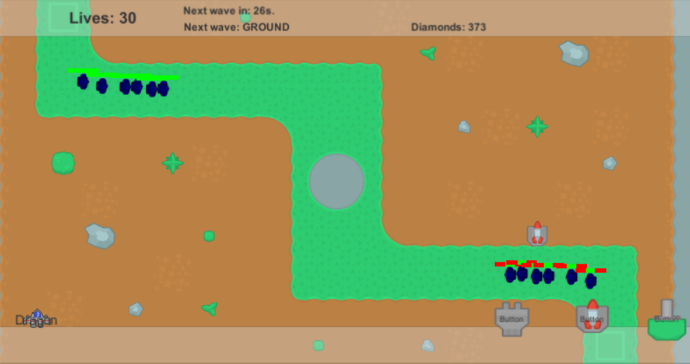

* **Player Lives and Game Over**
* Scenario: Launched the game and let enemies spawn, letting them attack the playes and take lives.
* Result(**EXPECTED**): When the number of lives gets to 0, a „Game Over” screen appears with options to go „Back to Menu” or „Play again!”

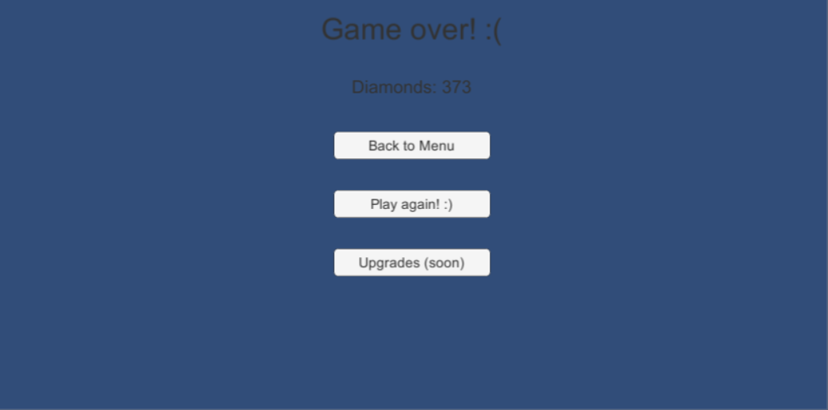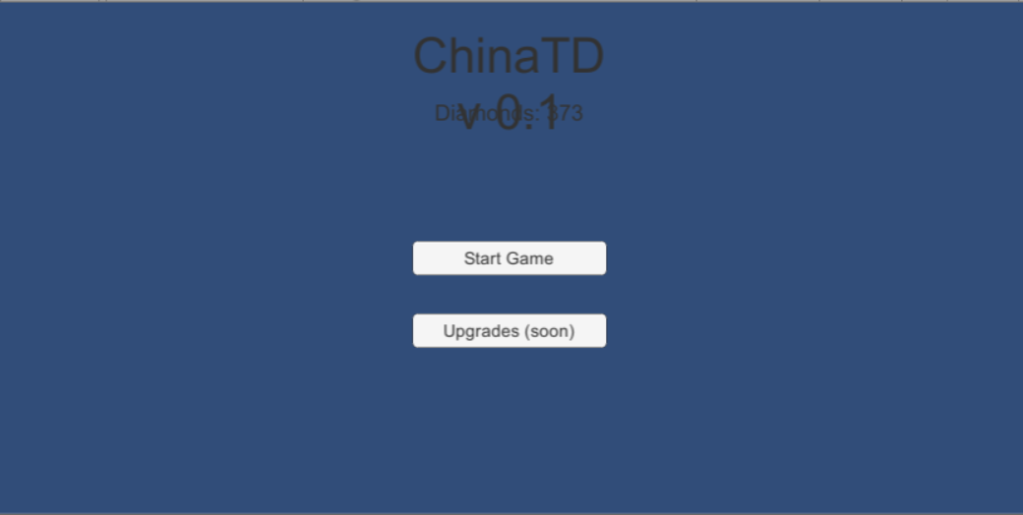

* **Diamonds**
* Scenario: Launched the game and let enemies spawn, and placed towers on the map.
* Result(**EXPECTED**): When an enemy died, it would drop diamonds (the drop rate and minimum/maximum amount set differently for each enemy type). In the event of a game over, the player keeps the diamonds, to be used for upgrades when playing again.